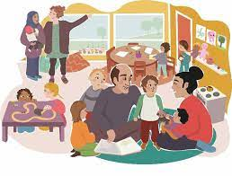
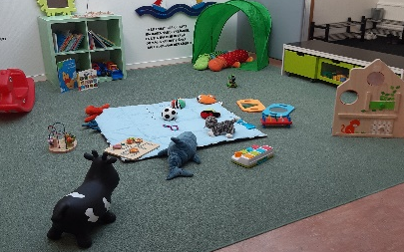
Do you want to learn
Swedish while you are on perantal leave?

Then you are welcome to the
open preschool at the family center,
The four-leaf clover in Strömsnäsbruk.
On Thursday Christine Award comes
and teaches/ work on Swedish with those of you who want to learn from the beginning, know a little or a lot.
Swedish for parental leave is Thursdays
27/10, 3/11, 10/11 and 17/11 between 10:00-11:30, we finish with a song collection at the open preschool.
Childern between 0–6 years who do not have preschool are welcome.
